Computer Science Jeroo Lab 2C – LED METHODS Lab Value - 100

Lab Goal : This lab was designed to teach you more about using method calls to solve problems. You must get comfortable with single Jeroo methods being called multiple times in solving problems that involve the same actions being repeated. Each method must perform an action autonomously. You must plan each method based on preconditions as well as post conditions.

Lab Description : Create methods that would allow your Jeroo to plant flowers to form any of the numbers from 0 to 9 in LED style characters in a 5 column by 7 row format. Each method must be able to start from the top left and when finished must move back to the top row along the right edge. Once in the top right corner of the 5 by 7 pattern, the Jeroo must hop 3 spaces to the right (EAST) and quit. This leaves the Jeroo in position for creating the next number and a spacing of 2 columns between each number.
Once your Jeroo methods for 0 – 9 are created – You will return to the main method and write the code needed to call 3 of your methods in order to plant the last 3 numbers of your phone number on the screen. You must make all 10 number methods before you can create the code in main method.
Sample Output :
Files Needed ::
Jeroo_Lab2C.jsc
Blank Island

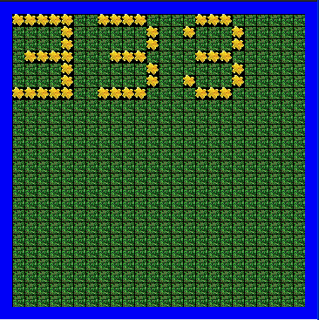
algorithm help

Use Grids to design each number before writing the methods.

Give each method a thorough test before moving on. Ex – bobby.drawFour();

Preconditions –
- # of Flowers needed
- must start at 0,0
- must skip 2 columns between the numbers

Postcondition –
- 3 numbers drawn on the screen
- Jeroo is not in the water

Hint – Always end each method with the Jeroo in the same position. A good place would be 3 columns over Facing East on the top row.

Bonus: Write a separate method for skipping columns and use it in your solution. +10

Computer Science I Jeroo Lab 2C – LED GRID TOOLS Lab Value - 100

